 | 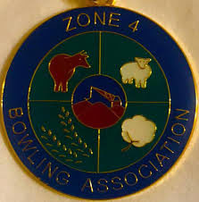
ZONE FOUR BOWLING ASSOCIATION Incorporated - 1800932
President – John Mobbs |  |  | Secretary – Jenni Mansell
Home Phone: (02) 6374 1673  Email– bowlswife63@gmail.com |  |  | Mobile Phone: 0405 162 100  Email: zone4ba.secretary@gmail.com

RESULTS OF SECTIONAL PLAY TRIPLES
+
VENUES & Times for Finals
01: Open Triples Section 01 at Grenfell:
Lead, Tim Fowler, Second Andrew Armstrong, Skip Steve Galvin

02: Open Triples Section 02 at Mudgee:
Lead Michael Thompson, Second Darryl Elbourn, Skip Sam Cook

03: Senior Triples Section 01 at Mudgee:
Lead Greg Campbell, Second Bernard Diduszcko, Skip Robert Hamilton

04: Senior Triples Section 02 at Condobolin
Lead Gary McPhee, Second Brett Frame, Skip Mark Fitzalan

05: Reserve Triples Section 01 at Cowra:
Lead Jake Brown, Second Peter White, Skip Paul Kirwan

06: Reserve Triples Section 02 at Dubbo City:
Lead Brad Davis, Second Gavin Davis, Skip Mick Waller

The Final of the OPEN & SENIOR Triples will Commence at 10.00AM
Saturday 23rd September at Parkes Railway Bowling Club

The Final of the Reserve Triples will Commence at 1.00PM
Saturday 23rd September at the Parkes Railway Bowling Club

Norman R Bohm: N.R.Bohm
Match Committee Chairman

